# Curriculum Vitae

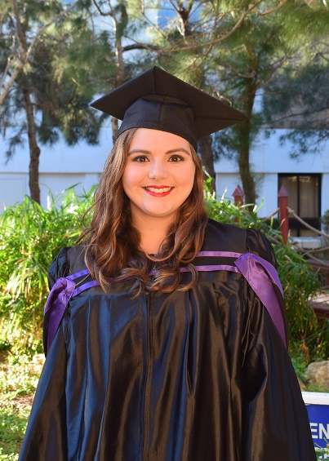Michelle Falzon

7, Triq il-Fjorin, Swieqi, SWQ 2602, Malta

+356 7909 9612

michelle_falzon@hotmail.com

## About

Hello! I am an artificial intelligence graduate from the University of Malta. I am a hard working individual who always strives to improve my skills. I have worked in the iGaming industry for almost two years.

Throughout my time at Raketech, I learnt to adapt quickly, think creatively and manage a team. Within a few months in the company, I was leading a small team with various skills and backgrounds. Our aim was to improve a small network of sites by making them engaging to our target audience, fast, responsive and increase their overall SEO performance.

The rest of my experience, though unrelated to my line of work, helped me understand the qualities needed to be a good leader and team player. I have also tried my hand at voluntary work which was incredibly rewarding. It was through this type of work that I learned proper time management and coping with new challenges.

In my free time I enjoy fencing and taking part in theatrical performances, as well as, reading and gardening.

I believe that teamwork, organization, having a willingness to learn and good time management are the keys to success!

## Experience

09/2017 - Present Web Developer and Team Performance Coordinator - Raketech

* Languages used: React, Vanilla Javascript with jQuery, SQL, PHP, HTML and CSS
* Developing an internal tool for simplifying the visualization of site metrics and SEO health and recommending websites from which purchased links would improve the sites overall rank metrics. This involved the use of third party APIs, React libraries, messaging queues (RabbitMQ), database design and management.
* Maintaining, designing and developing new features for websites with a focus on Search Engine Optimization
* Overseeing team performance and coordinating tasks (both in-house and with freelancers)
* Managing the acquisition of links for each site
* Maintaining the overall SEO health of the sites by abiding to the guidelines set by Google
* Working with third parties to optimize products and sales
* Minor server side jobs such as creating CRON jobs and service files
* Winner of the Ownership and Teamwork Raketech Awards
* Winner of the Innovation Day Award

07/2016 - 09/2016 Intern Front End Developer - Betsson Group

* Bug fixing
* Minor testing
* Styling of new features

10/2015 - 12/2017 Attendant I.T. Services - University of Malta

* Supervising computer labs
* Troubleshooting

09/2015 - 03/2016 Junior Clerk - HLB Falzon & Falzon (Family Business)

06/2015 - 08/2015 Teen Group Leader - BELS

* Supervising foreign students ages 12 to 17 on activities.

03/2015 - 06/2015 Children’s’ Animator After Glow Events

* Taking care of children between the ages of 3 and 10 years old
* Dancing
* Games
* Balloon modelling

04/2014 - 03/2015 Children’s’ Animator - PartyTrap

07/2013 - 09/2013 Assistant - HLB Falzon & Falzon (Family Business)

* Filing and updating archives

## Education and training

2018 Informal Leadership Training - StreetHR (Malta)

2018 The Web Developer Bootcamp - Colt Steele (Udemy)

* HTML5
* CSS3
* JavaScript
* Bootstrap
* SemanticUI
* jQuery
* NodeJS
* NPM
* ExpressJS
* REST
* MongoDB
* Database Associations
* Authentication
* PassportJS
* Authorization

2018 Vue JS 2 - The Complete Guide - Maximilian Schwarzmüller (Udemy)

* Vue JS 2
* Vue Router
* Vuex

2014 - 2017 BSC ICT (Artificial Intelligence - Honours) EQF level 6 - University of Malta

* Programming in Java, C, C++, HTML, CSS, SQL, PROLOG, MATLAB
* Web Development
* Signal Processing
* Data Structures and Algorithms
* Mathematics for Engineers
* Discrete Mathematics
* Databases
* Natural Language Processing
* Intelligent Agents
* Web Intelligence
* Advanced Game AI
* Entrepreneurship
* Object Oriented Programming
* Business Intelligence
* Machine Learning
* Content Based Image Retrieval and Categorization

2015 CS50 - Computer Science Introduction Course - Harvard University

* C programming
* Web Development - HTML, CSS , PHP, JS

2012 Web Design Summer Course - STC

2012 - 2014 De La Salle College Sixth Form EQF level 4

* Advanced level: Computing and Pure Mathematics
* Intermediate level: English, Physics and Systems of Knowledge

2001 - 2012 School Leaving Certificate Level 3 - St. Joseph School

* English
* Maltese
* Maths
* Religion
* Chemistry
* Biology
* Physics
* French
* Computer Studies

## Hobbies

2008 - 2017 Olympic Fencing - St. Paul Fencing Club

2012 - 2018 Drama and Theatrical Productions - DLS Productions/ KSU Students’ Fest

2017 - 2018 Historical Fencing – Malta Historical Fencing Association

Other Reading, Gardening, Tennis, Gaming, Art

## Voluntary Work

07/2013–09/2013 Volunteer - Nature Trust Malta (Malta)

* Taking care of the injured turtles at Fort Lucjan
* Taking care of children and collecting donations during the ‘Kids on the Coast’ events

07/2013–11/2013 Child-care worker - MSSP Oratory

* Taking the young children during the homily and teaching them about the readings in a simple manner as well as planning games for them

01/2014–10/2014 Deputy Mayor - Swieqi Youth Local Council

2015 -2017 Subcommittee - ICTSA (ICT Students' Association)